

END SEMESTER ASESSMENT

SEMESTER – 2

B.TECH (CSE)

**TOPIC – CAR RENTAL APP**

SUBMITTED BY-

Parmesh Goyal – E23CSEU0042

Kshitiz Bhadoria – E23CSEU0051

CSET 109 - JAVA

~Project Report

**INTRODUCTION**

The car rental management system project aims to address the growing demand and evolving needs of the car rental industry. The introduction to the report should provide some background on the industry and the challenges faced by various stakeholders, such as individual customers, businesses, and rental agencies, in managing their rental operations effectively. The project's key objectives should be highlighted, emphasizing how the developed system intends to streamline the rental process, improve customer experience, optimize fleet management, enhance operational efficiency, and enable data-driven decision-making.

**APPLICATION AREA**

The application area of the car rental management system is quite diverse, catering to a wide range of users and stakeholders. The report should delve into the specific needs and requirements of individual customers, corporate clients, rental agencies, and fleet managers, and explain how the system's features and functionalities are designed to address these diverse needs. For instance, individual customers may benefit from seamless reservation booking, flexible pickup/drop-off options, and self-service account management, while corporate clients could appreciate the centralized fleet management, customizable rental policies, and detailed reporting for expense tracking. Rental agencies, on the other hand, may leverage the system's automated inventory management, streamlined rental operations, and comprehensive analytics for business insights. The versatility of the system in accommodating various rental scenarios, from short-term personal rentals to long-term corporate leases and specialty vehicle rentals, should also be highlighted.

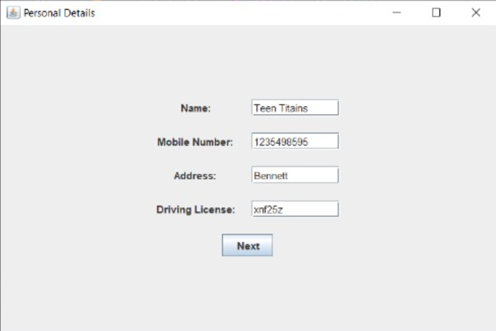 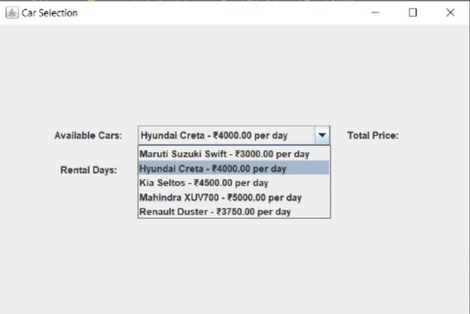

**TECHNOLOGIES USED**

The technological stack employed in the development of the car rental management system is a crucial aspect of the project. The report should provide an overview of the programming languages, frameworks, databases, and other tools utilized, and explain how these technologies contribute to the system's functionality, scalability, and security. For example, the use of web-based architecture leveraging technologies like HTML, CSS, JavaScript, and popular frameworks like React or Angular, ensures a responsive and user-friendly interface. The robust backend systems, built using Java, Python, or .NET, provide reliable data management and business logic. Efficient database solutions, such as MySQL, PostgreSQL, or MongoDB, are employed for storing and retrieving rental data. The integration with third-party services, like payment gateways, GPS tracking, and customer relationship management (CRM) systems, further enhances the overall functionality of the system. The selection of these technologies should be aligned with industry best practices, ensuring the system's maintainability, extensibility, and performance

**SYSTEM DESIGN & ARCHITECTURE**

The system design and architecture of the car rental management system is a crucial component of the report. It should provide a high-level overview of the system's architecture, highlighting the key components and their interactions. The client-server model, where the user interface (client) communicates with the backend server to handle various rental operations, should be explained. The data storage and management approach, such as the use of relational or NoSQL databases, and how they support the system's data integrity and scalability, should be discussed. The communication mechanisms employed, including RESTful APIs, web services, or event-driven architectures, to facilitate smooth data exchange between the system's components, should also be described. The report should emphasize the design principles and patterns, such as modularity, abstraction, and separation of concerns, that have been implemented to ensure the system's flexibility, maintainability, and future extensibility..

**IMPLEMENTATION DETAILS**

The implementation details of the car rental management system should delve into the specific functional modules and their underlying logic. The reservation management module, which handles customer booking requests, availability checks, and confirmation processes, should be explained. The inventory control module, responsible for managing the fleet of vehicles, including vehicle details, status tracking, and maintenance scheduling, should be described. The pricing and billing module, which handles rental rates, discounts, taxes, and invoice generation, should be discussed. The reporting and analytics module, which generates various reports and provides business intelligence to support data-driven decision-making, should also be highlighted. Insights into the algorithms, data structures, and optimization techniques used to ensure efficient and scalable system performance should be provided.

**FEATURES**

The car rental management system offers a comprehensive set of features designed to enhance the user experience and streamline the rental process. These features include the ability for customers to search for available vehicles based on their preferences, such as location, dates, and vehicle type. The system also enables users to seamlessly book and manage their rental reservations, including the option to modify or cancel bookings as needed. Additionally, the system provides a user-friendly interface for rental agencies to manage their fleet, track vehicle availability, and process rental transactions. Robust reporting and analytics capabilities empower businesses to gain valuable insights into their rental operations, customer trends, and revenue performance. The system's features are continuously evolving to adapt to the changing needs of the car rental industry and provide an exceptional experience for all stakeholders.

CHALLENGES & SOLUTIONS

The development of the car rental management system presented several challenges that the project team had to address. One of the key challenges was the need to maintain a delicate balance between user-friendliness and comprehensive functionality, ensuring that the system was intuitive and accessible for both individual customers and rental agency staff. The team tackled this by conducting extensive user research, iterative design processes, and usability testing to refine the interface and workflow. Another challenge was the integration of various third-party services, such as payment gateways and GPS tracking providers, to seamlessly incorporate their capabilities into the system. The team overcame this by adopting a modular and extensible architecture, which allowed for smooth integration and future adaptability. Additionally, ensuring the scalability and performance of the system as it handles growing volumes of rental data and user traffic was a significant challenge, which was addressed through optimized data management, load balancing, and cloud-based infrastructure solutions.

**FUTURE IMPROVEMENTS**

As the car rental management system continues to evolve, there are several potential areas for future improvements and enhancements. One area of focus could be the integration of advanced predictive analytics and machine learning algorithms to provide more sophisticated insights and recommendations to rental agencies. This could include forecasting demand, optimizing fleet deployment, and personalized pricing strategies. Additionally, the team may explore the integration of real-time GPS tracking and geolocation services to offer enhanced features like automated check-in/check-out, dynamic routing, and improved customer communication. Enhancing the mobile experience, with the development of dedicated mobile applications for both customers and rental staff, would further improve accessibility and convenience. Implementing robust security measures, such as biometric authentication and end-to-end encryption, would also be a valuable improvement to ensure the protection of sensitive rental and financial data. By continuously addressing user feedback and industry trends, the car rental management system can be continuously refined and expanded to maintain its competitive edge and provide the best possible experience for all stakeholders.

CONCLUSION

The car rental management system project has successfully delivered a comprehensive and user-friendly solution to address the challenges faced by the car rental industry. By providing a range of features that cater to the needs of individual customers, corporate clients, and rental agencies, the system has streamlined the rental process, improved operational efficiency, and enabled data-driven decision-making. The integration of cutting-edge technologies, a robust system architecture, and a focus on user experience have positioned the car rental management system as a valuable asset for businesses, empowering them to enhance their competitiveness, improve customer satisfaction, and drive profitability. As the industry continues to evolve, the team behind this project remains committed to exploring new opportunities for innovation and ensuring that the system remains at the forefront of the car rental landscape.